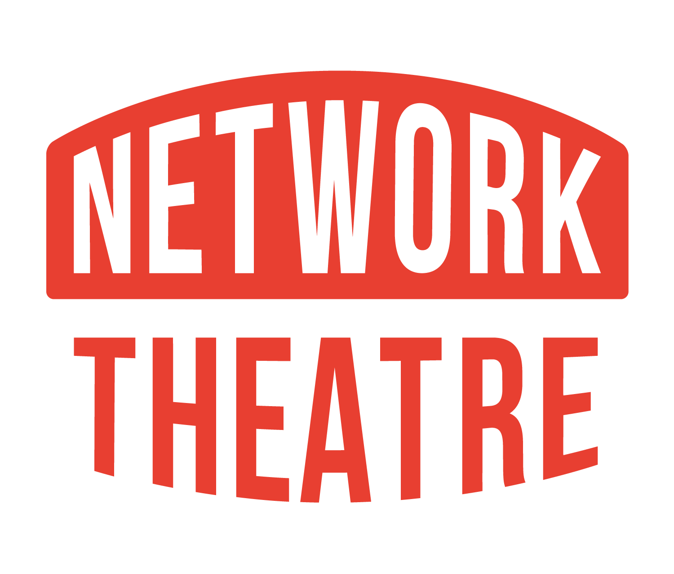

**Network Theatre Company**

**Network Theatre, 246a Lower Road, Waterloo, London SE1 8SJ**

**www.networktheatre.org**

**Director’s Show Proposal**

* Please complete the boxes below with information about your show
* All proposals must be received by 1 July to be considered for the following year.
* If the show requires a licence, please check the status of the licence before proposing.
* Directors can only direct one show per season, and no more than two shows over a three year period.
* If you have any questions that are not answered below, please do check the production pack found here <https://ntc.wildapricot.org/>

|  |  |  |
| --- | --- | --- |
| Title | Playwright | Licence Status |
|  |  |  |

|  |  |
| --- | --- |
| Parts | Specific gender/ages |
|  |  |
|  |  |

|  |
| --- |
| **Summary:**  **200-500 words to summarise the show, genre, audience appeal, straight play or musical** |

|  |  |
| --- | --- |
| Technical Challenges |  |
|  |  |

|  |  |
| --- | --- |
| Length of run | Network traditionally has 4 performances running from Wednesday - Saturday |
|  |  |

You do not need to be a member of Network Theatre to propose a show, but will need to be an active paid-up member to go ahead once the proposal is accepted.

The Budget for the show comes mainly from participation fees but is generally around £200. Any expenses will need to be clearly defined before the production begins. If you already have a costing document or summary, please include it either here or attached to the proposal email.

**Network Theatre Show Timeline**

Shows at Network generally start with a read-through of the script a few months before the run, which is open to everyone to attend. Two audition nights are held about two-three months before the show dates. Shows start rehearsing, 3 nights a week, approximately six weeks before the show.

The Diary Manager will provide concrete dates once the proposal is accepted.

Before the auditions, the Director and producer will be invited to a meeting with the Committee to talk about their show, their vision, their budget and will be assigned a Committee liaison person for the duration of the project.

This is a good opportunity to talk with the technical team as they can provide advice on your technical and backstage needs. Tech are always contactable at [tech@networktheatre.org](mailto:tech@networktheatre.org)

Marketing also needs to be addressed from the beginning. The production pack contains many tips, and you can contact [marketing@networktheatre.org](mailto:marketing@networktheatre.org) if you have any questions.

You can always attend Committee meetings throughout the rehearsal period. Meetings take place on the first Tuesday of the month.

After the show is cast, marketing and membership will be in touch about promoting the show and ensuring the actors and crew are paid up members and have paid their show participation fee. Production meetings should begin as soon as rehearsals do, and please encourage actors to participate in set build days. They **must** attend the technical rehearsal the weekend before the run.

Any questions please contact programme@networktheatre.org